ChatBotAs a service

short line

In22Labs Pvt LTD  
26th September, 2022

# Introduction

Objective is to create a ChatBot as a web-service. ChatBot should have a generic knowledge base or should have ability to do generic conversation. Additional knowledge base will be considered as an add-on for the chatbot.

# Overview

A generic webclient should have the ability to send / receive a message. Once a message is sent it should reach the interface. Interface checks the user requests with the cache platform. If it has a response, it will revert the answer to the user. Otherwise, it checks requests with the ChatBot engine(NLP engine / Rule based engine). Once the answer is found it throws back the response to the both webClient and Database platform. Databases should have the ability to update the cache periodically.

# Components

Below is the list of components to be built in the chatbot.

* WebClient.
* Core interface.
* ChatBot engine.
* Data storage.
* Cache storage.
* Admin Portal.

# Proposed technologies

* WebClient has to be built on top of either VueJs or ReactJS.
* Core Interface/API has to be created with Elixir(Phoenix).
* ChatBot Engine (Yet to be decided - Rule / NLP)
* Data storage (YugaByte DB / PostgreSQL / MySQL)
* Cache storage (Redis cache)
* Admin portal has built with either VueJS/ ReactJS / Elixir

# Architecture

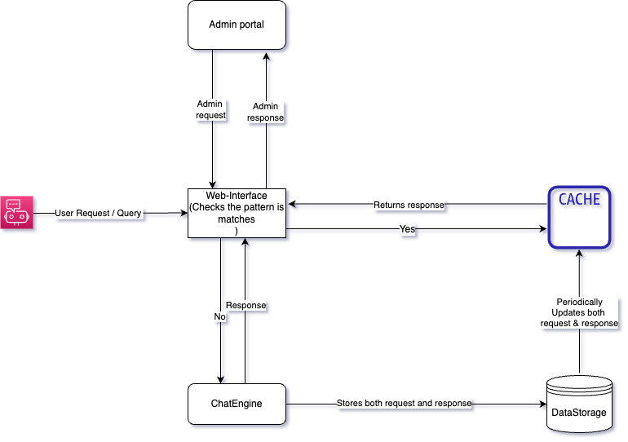

# Reference

* [Architecture Source](https://drive.google.com/drive/folders/1wMGc5M3HpERWJHLXfLBPNEl0jUQ1U11t)

short dash

# **RASA Architecture through Diagrams**

